**PORTFOLIO**

**COMPUTER SCIENCE AND ENGINEERING**

Submitted by:

Name: CHINU YADAV

Registration number: 12406486

Roll No.: RK24CTA12

Section: K24CT

**Submitted to : Dr . JOSHVA RAJG**



**LOVELY PROFESSIONAL UNIVERSITY**

**DECLARATION**

I, Chinu Yadav, a student of Bachelor of Technology under CSE discipline at Lovely Professional University, Punjab, hereby declare that all the information furnished in this project report is based on my own work and is genuine

CHINU YADAV

Registrartion Number: 12406486

|  |  |  |
| --- | --- | --- |
| Platforms for profile creation | Link to student profile | Screenshot |
| ***Figma*** | https://www.figma.com/files/team/1408362883784079962/recents-and-sharing/recently-viewed?fuid=1408362879589251327 | 1 |
| ***Quora*** | https://www.quora.com/profile/Chinu-Yadav-57 | 1 |
| ***Stack overflow*** | https://stackoverflow.com/users/27651255/chinu-yadav | 1 |
| ***Hacker Rank*** | https://www.hackerrank.com/profile/ydvchinu64 | 2 |
| ***Hacker Earth*** |  | 1 |
| ***Geeks for Geeks*** | https://www.geeksforgeeks.org/user/ydvchika43/ | 1 |
| ***LinkedIn*** | https://www.linkedin.com/in/chinu-yadav-416990322/ | 1 |
| ***Github*** |  | 1 |
| ***Git*** |  |  |
| ***CV*** |  | 1 |
| ***MOOCS done*** | 1. INTRODUCTION TO COMPUTER SCIENCE | 1 |
| ***NON Technical MOOC PIC*** | AT THE END |  |

1.FIGMA

Profile:

Figma internal profile with project

Accomplishment:

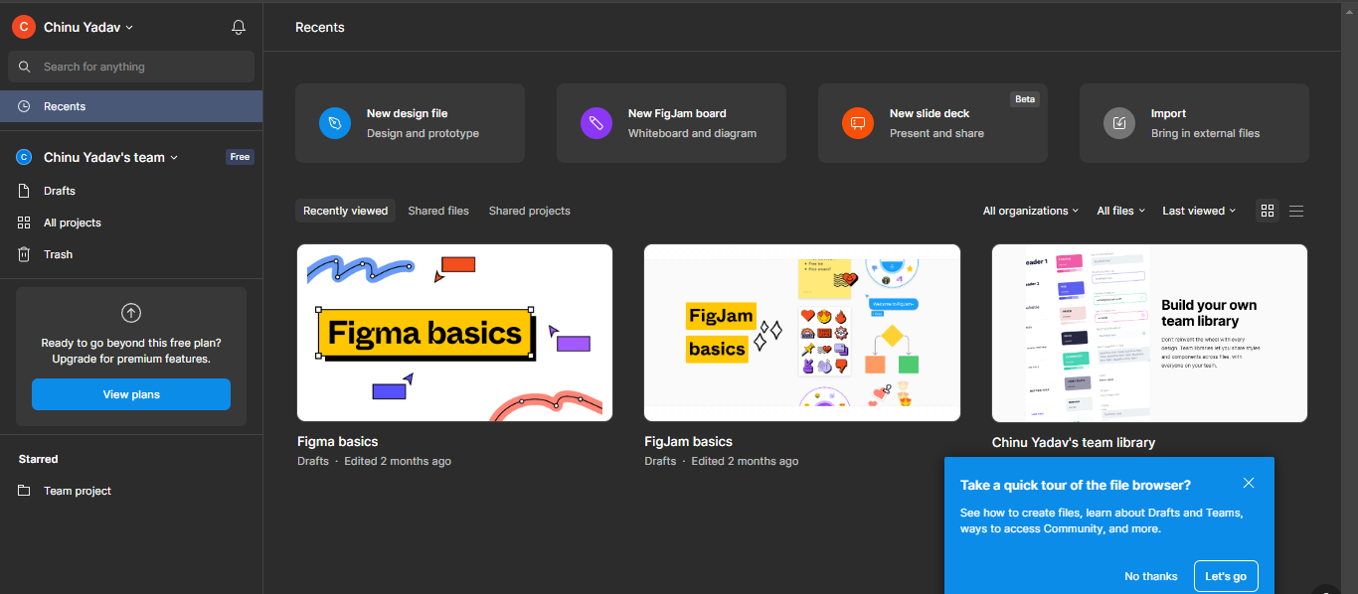

2.QUORA

PROFILE AND ACCOMPLISHMENT:

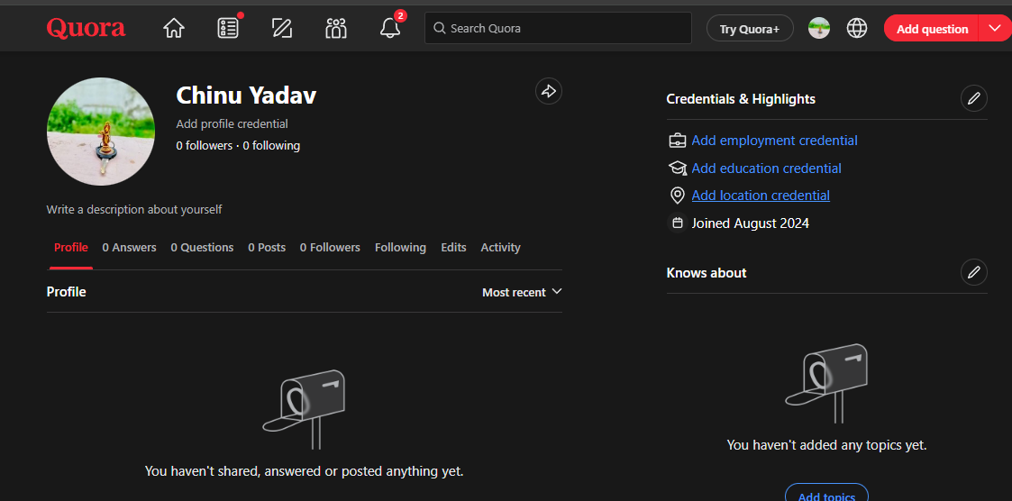

3.STACKOVERFLOW

PROFILE:

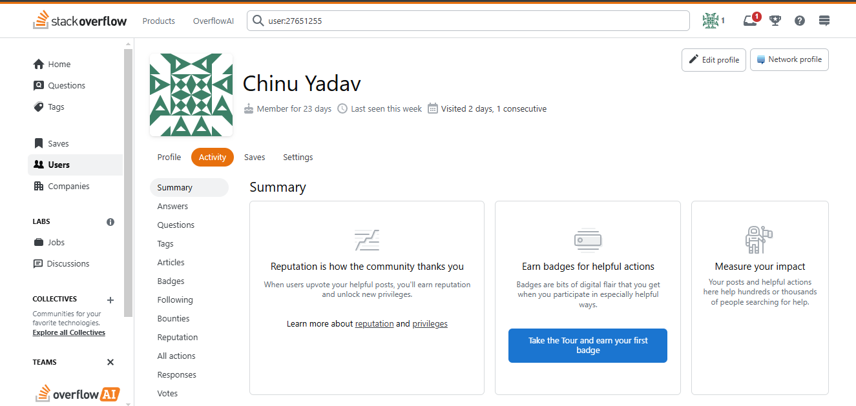

**4.HACKER RANK**

**Profile:** 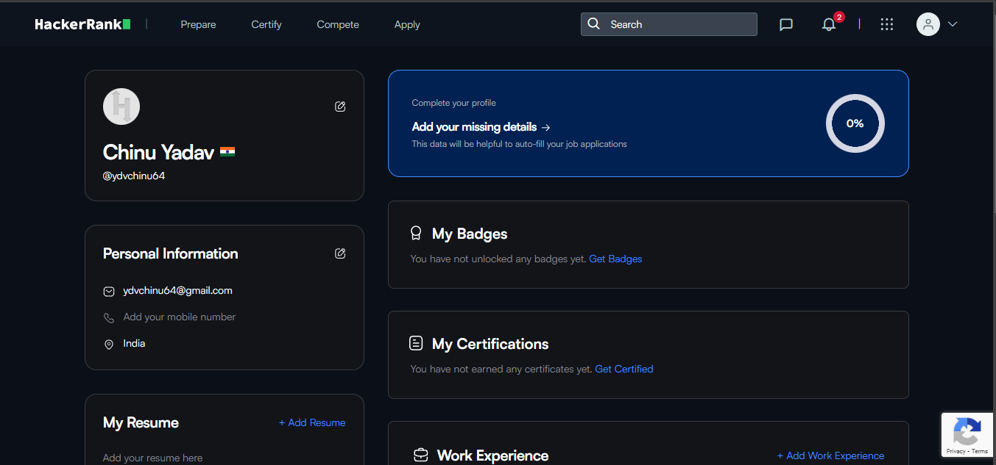

**5.GEEKS FOR GEEKS**

**Profile:**

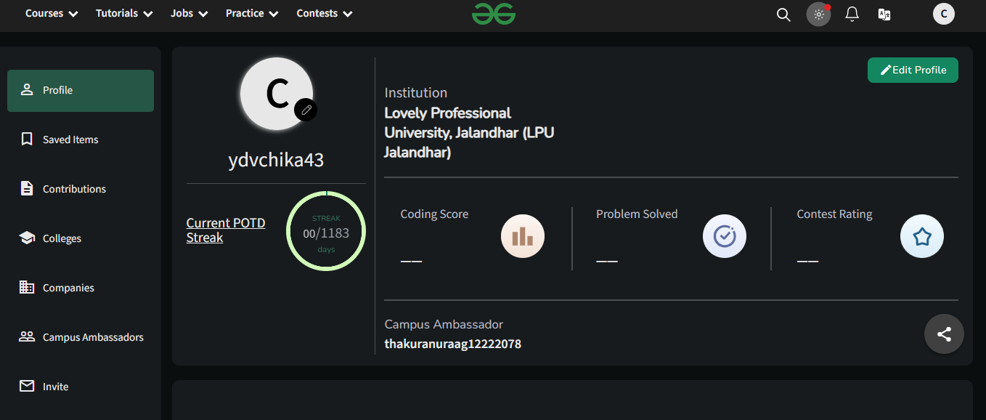

**6. GITHUB**

**Profile:**

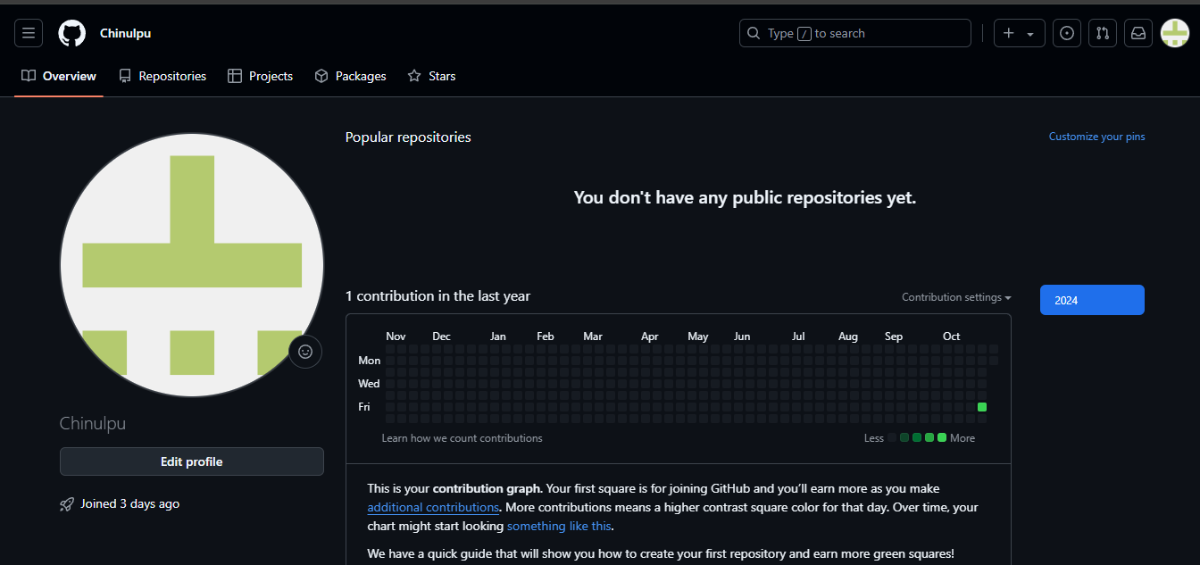

**10.CV**

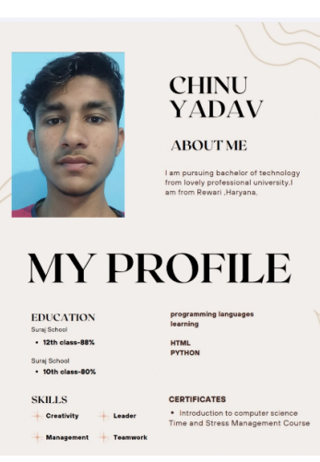

**11.MOOCS completed**

**11.NON-Technical MOOC PIC**